Задание 4. Письмо
Раскрасьте картинку и опишите изображенного на ней слоненка, используя выражения:
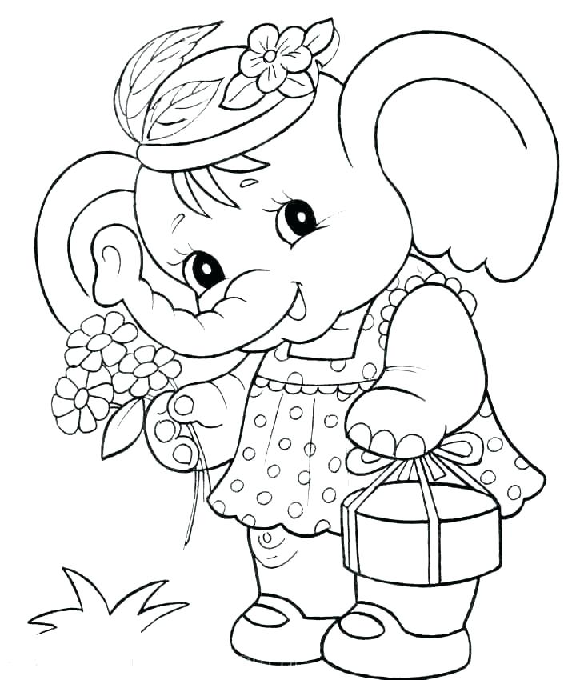
Elephant, years old, flowers, have got, big, mother, like, can, live, dress, run, ears, nose.

Внимание! В этом задании можно получить еще два балла за два дополнительных предложения со своими словами.

Hello, I am Baby Elephant.

1. __________________________________________________________

2. __________________________________________________________

3. __________________________________________________________

4. __________________________________________________________

5. __________________________________________________________

6. __________________________________________________________

7. __________________________________________________________

8. __________________________________________________________

9. __________________________________________________________

10. _________________________________________________________

____________________________________________________________

____________________________________________________________

December 7, 2019

Открытая олимпиада по английскому языку

4 класс

Фамилия, имя участника_______________________________________

№ школы, город _________________________________

Enjoy the competition and good luck to you!

Задание 1. Аудирование
Послушайте разговор друзей.
Ответьте на вопросы по образцу:

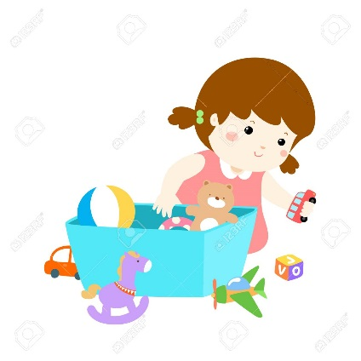

What is the girl’s name? - _____Lucy_________________
How old is she? - ______6__________

1. How many dolls has Lucy got? - __________________
2. What’s the dog’s name? - ____________________
3. Which class is Lucy in? - _____________________
4. What’s the name of Lucy’s school? - __________________
5. How many children are in Lucy’s class? - __________________________
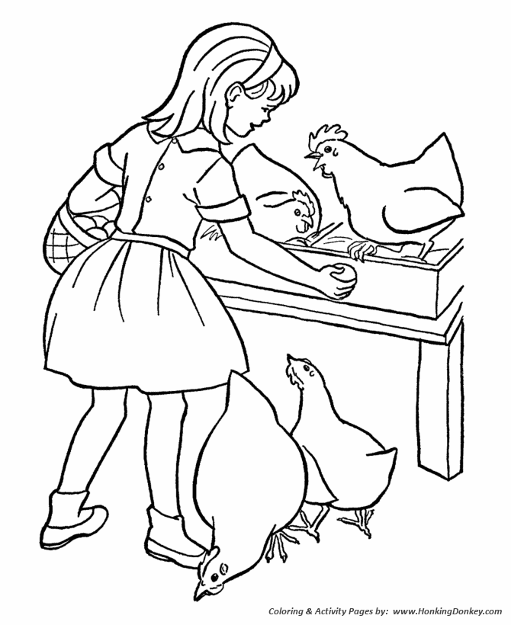
Задание 2. Чтение
Прочитайте рассказ.

Vicky goes to school in New York. It is a big city with lots of people. Every weekend she goes to see her grandparents. She rides a train to the country because her grandparents live on a farm. They live in a big house next to a river. Today Vicky wants to give her grandmother a present (подарок). It is a in a pretty box. There is a painting in it. “It is for you,” says Vicky. “It’s a horse!”
Grandma makes vegetable soup for lunch and gives Vicky a glass of milk to drink. Vicky likes drinking fresh milk very much.

In the evening Grandma and Vicky go to the garden, “The chickens are here! Would you like to get their eggs?” asks Grandpa. “Yes, please!” says Vicky and gets four eggs. She puts them in a basket. They can eat them for breakfast. It is time to go to bed! But Vicky is not sleepy. She wants to ride a horse! The horse is beautiful and very kind. And the stars are so big and bright! What a fun day on the farm!
Прочитайте утверждения, данные ниже. Если утверждение правильное, напишите рядом с ним слово Yes, если же утверждение неверно, напишите рядом с ним слово No.
- Vicky lives in a small town. _________
- Vicky is an American girl. _________
- Her grandparents live with Vicky and her family. _________
- Vicky rides a bike to her grandparents’ house. _________
- Vicky has a picture of an animal for her grandmother. _________
- Vicky never drinks milk. _________
- There are no chickens on the farm. _________
- Vicky carries the eggs in her bag. __________
- Vicky does not want to go to bed. _________
- Vicky rides the horse in the dark. _________
Раскрасьте картинку:
- Vicky’s hair is black.
- The egg in her hand is brown.
- Vicky’s socks are red.
- The chickens are white, gray and yellow.
- The table is purple.
- Vicky’s dress is green.
Дополните картинку рисунками в соответствии с предложениями:
1. There is a red box next to Vicky’s shoes.
2. There is a pink flower under the table.
3. There is a star over Vicky’s head.
4. There is a gray mouse on the ground

Задание 3. Лексика и грамматика Прочитайте предложения, выберите правильный вариант и обведите его в кружок:
1. We must… books at school.
a) reads b) reading c) read
2. I … drink orange juice in the evening.
a) don’t b) do c) doesn’t
3. How … bananas can you eat?
a) much b) old c) many
4. Jess … a big family.
a) have got b) has got c) has get
5. My best friend is Jane. … new dress is very pretty.
a) she b) her c) she’s
6. … you hungry?
a) is b) do c) are
7. My cat is …, it is not … .
a) slim, fat b) slim, small c) slim, old
8. Dogs … ride a bike.
a) can b) cannot c) must
Составьте и запишите предложения из слов.
1. you/ go/ do/ Sunday/ to/ on/ morning/ school?
2. Mary’s/ is/ or/ house/ gray/ green?
3. ducks/ can/ swim/ the/ river/ their/ babies/ and/ in?
4. I/ have/ cookies / never/ breakfast/ milk/ and/ for.
5. and / are/ beautiful/ very/ dolphins / animals/ clever.
1. __________________________________________________________
2. __________________________________________________________
3. __________________________________________________________
4. __________________________________________________________
5. __________________________________________________________

